1. I am sending you the new landscape logo format to replace the two logos on the banner. Its now logo first then text. I will mark the logo 1.
2. I am sending you 6 pictures to replace the pictures on the front. Please place them in the exact order I will send them. I will make the pictures 2
3. Concerns the captured part of the landing page

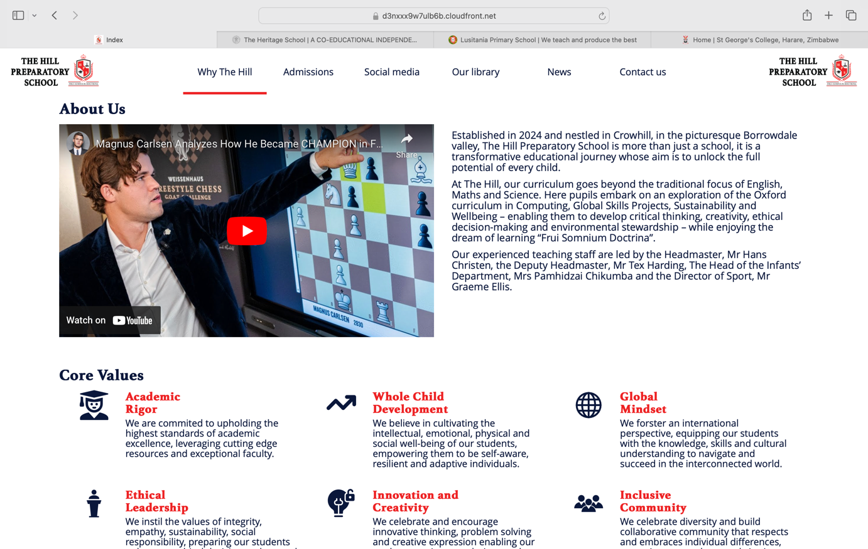

* Remove the video link
* Remove the Core Values
* Move the about to the left, justify the text, and lets change the font. Will send a font. Add a read more under the about that leads to the about page.
* On top of the about **Welcome to** then in bolder font **The Hill Preparatory School**
* Under that and before the about; **At the Hill we believe in holistic child development that turns every student into an active global citizen**.
* On the right put the picture I am sending and labelling 3. It’s a place holder will send a more updated place holder soon.

1. Concerns the captured part of the landing page

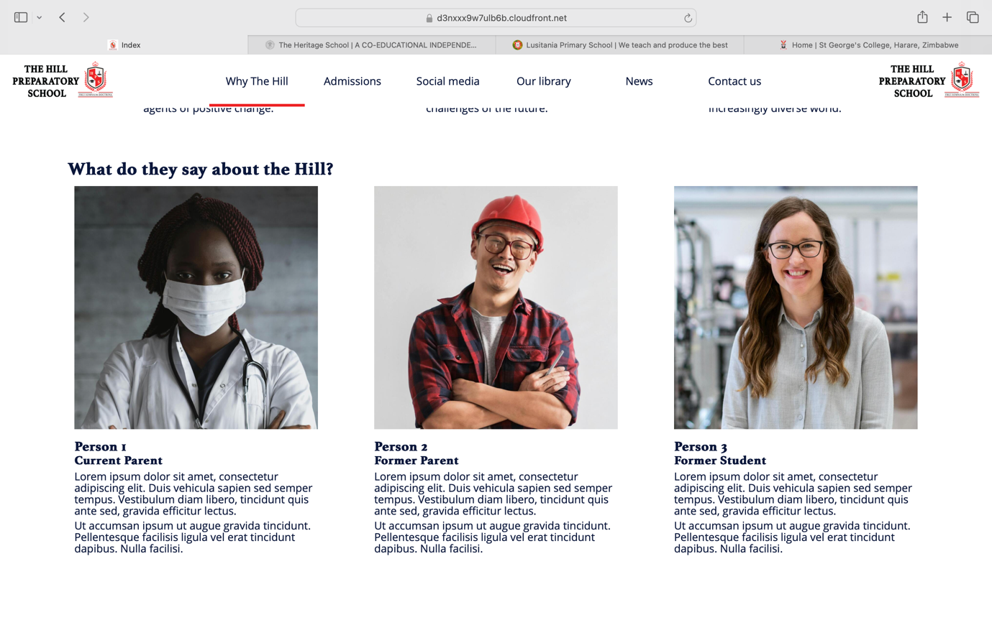

* Lets remove the parent student testimonials since the school is just opening we wont have those.
* I suggest that we put a page dedicated to our curriculum
* So our curriculum
* The Hill offers the Oxford International Curriculum, a leading curriculum in holistic child development
* Put a video link to the oxford international curriculum videos which I will send and mark 4.
* Also put a read more button which will contain information on the curriculum which I will send in a document marked 4.
* You can visit <https://global.oup.com/education/primary/curricula/oxford-international-curriculum/?region=uk> for inspiration of what to put on that section of the landing page.

1. Concerns the below captured

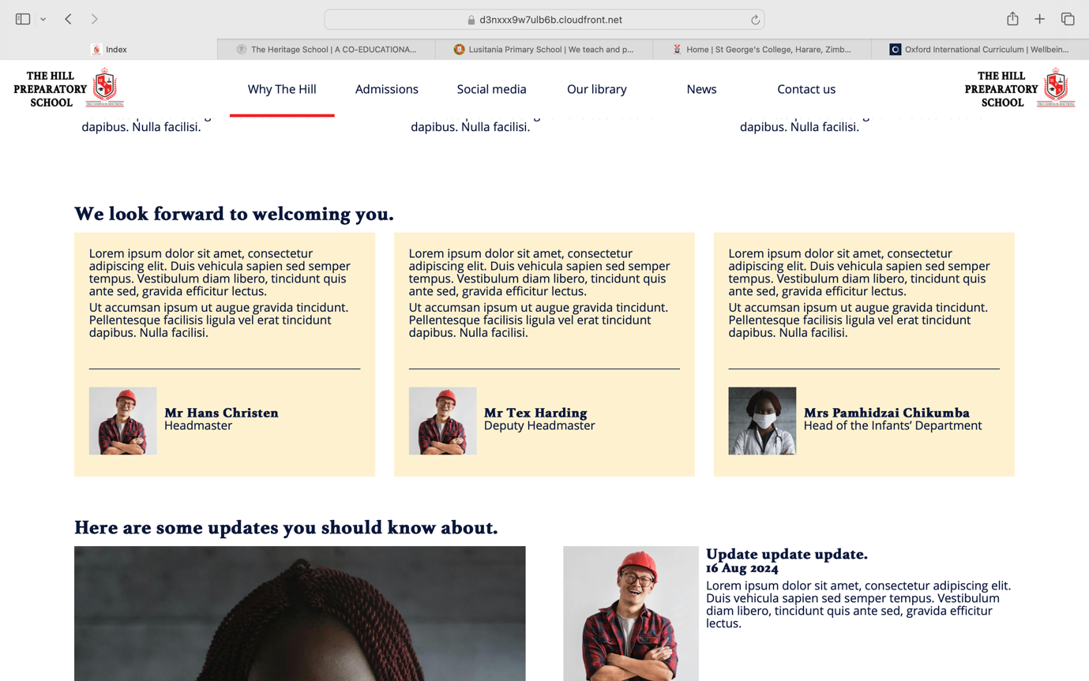

* Love the idea of the quotes will get the quotes and send as 5.
* Can you remove deputy headmaster, push Head of Infants (remove Department) to the left and then put sports director.
* Then on the Updates will send you 4 Place holder updates and pictures I will label 5.

1. Captured Below

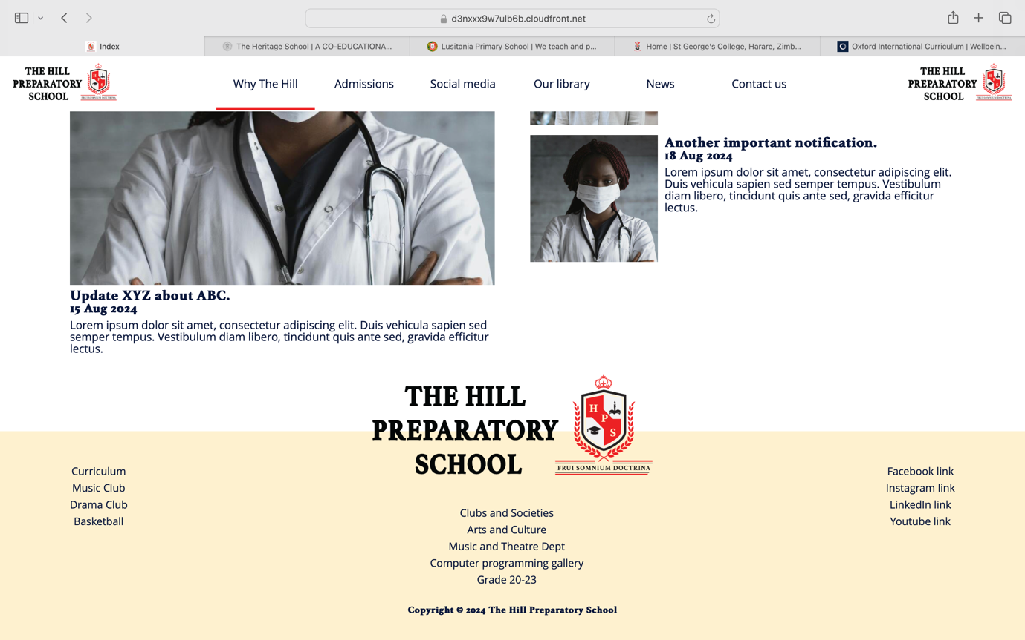

* Use the Normal Logo and not landscape version
* Move the Logo to the extreme left of the beige bar
* Put our contact details which I will send marked 6
* Put icons to the social media which links I will send marked 6
* Put the oxford international curriculum logos which I will send marked 6.
* Quick Links – Gallery, Our Calendar, Our library, News, Admissions,

1. Then the Tabs on the main bar on Top should be (drop down are the inner bullets)

* The Hill
  + About Us
  + Our Vision & Mission
  + Our Faculty
* Academics
  + Infant Department
  + Junior Department
* Sports
  + Our Teams
  + Our Results & League Tables
  + Sports Houses and Mascots
  + Sports News
* Arts & Culture
  + Music & Theatre Department
  + Arts & Craft Department
  + ICT
  + Clubs & Societies
* Admissions
* Contact Us